# Public Knowledge Base user document

## Introduction

A public knowledge base is one of the channels where you can provide knowledge articles to users or customers. Salesforce.com provides a package on the AppExchange so you can use Salesforce.com Sites to provide a simple public knowledge base using your organization’s existing knowledge base. This unmanaged package includes custom objects, tabs, and Visualforce pages that you can customize based on the needs of your organization.

## Key Features (out of the box when the unmanaged package was installed)

1. Search for the exposed Knowledge articles and view them  
   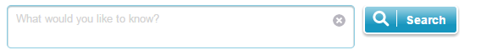
2. Filter the search results based on Data Category of Knowledge Article  
   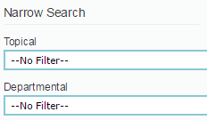
3. Contact Us  
   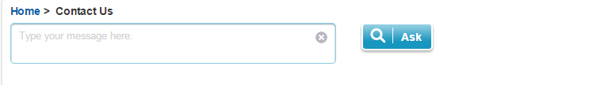  
   this feature will create a new case in Salesforce after the Contact Us form is filled. Before submitting a case, related articles are shown   
   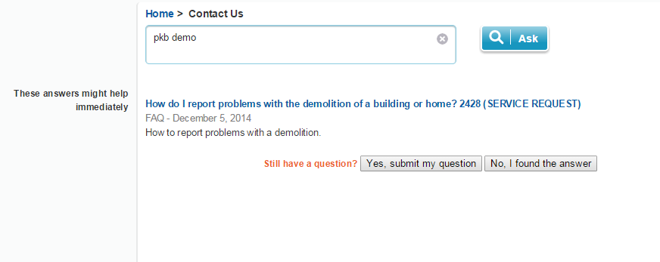  
   If the user still has a question, he can submit a question by clicking on “Yes, Submit my question” button and filling up the details of the form populated.  
   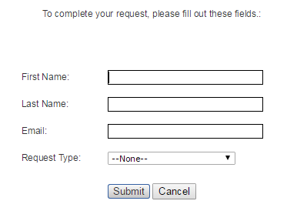  
   After the form is filled and submitted, a case will be created in Salesforce with the Request type selected.  
   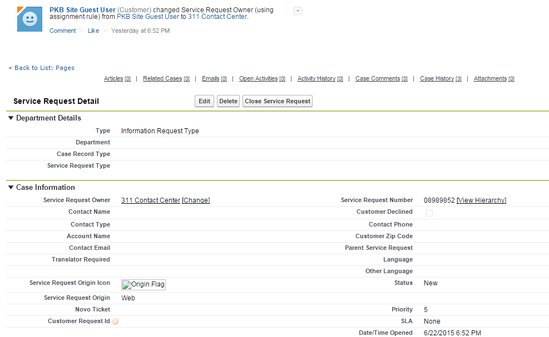
4. Feedback: This feature would determine whether the article was useful for the user.  
   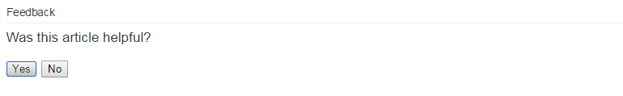
5. Pkb Mobile: Helps the mobile version users to search and view an article and also give the feedback  
   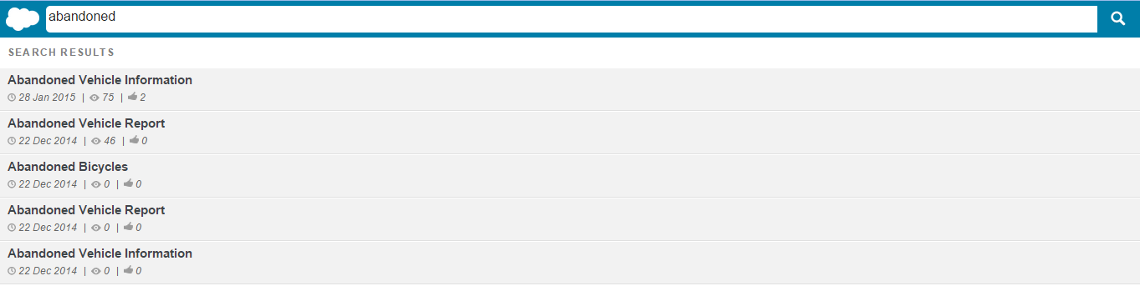  
     
     
   Also shows the number of views and number of people who have found the article useful  
   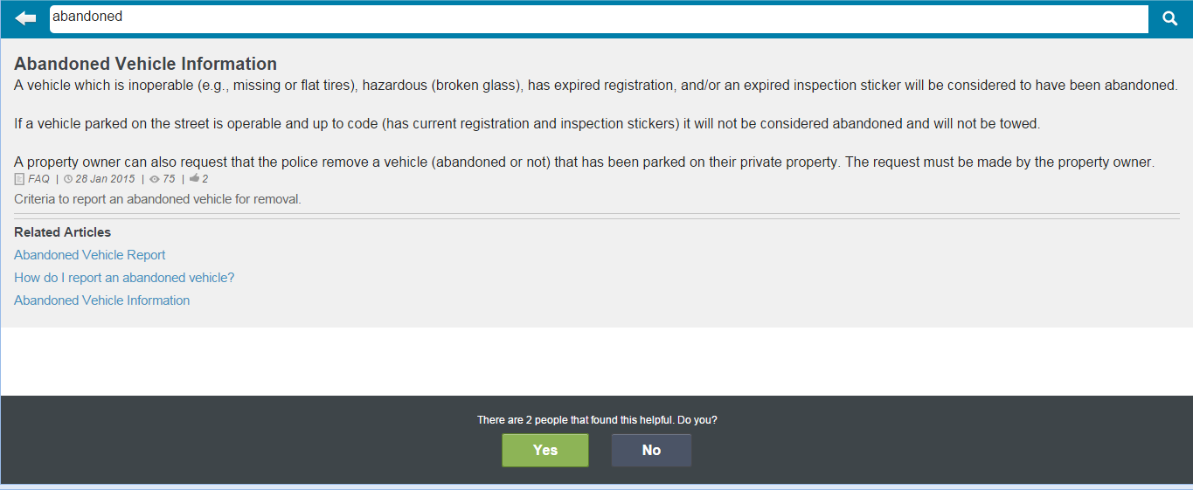

Additional Features:

1. Regarding feedback feature that allows customers to advise what is wrong with the articles of information on the knowledge base on Philly’s website and mobile app is not out-of-box feature.

In order to give that feature, additional Salesforce Customization to be done for tracking feedback emails. Unisys can help in doing this customization.

1. Regarding Article Rating – out-of-box functionality includes display on number of *views* and *likes*

For Article Rating feature as given in stars (for KB but not for PKB) in Agent portal was customized by Unisys. That feature is not available for PKB. In order to give that feature, additional Salesforce Customization to be done for providing rating in terms of Stars.